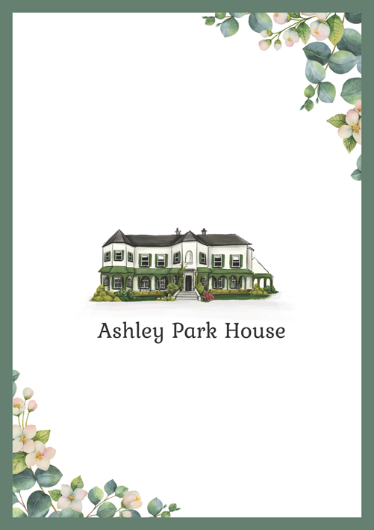

SAMPLE 2026

Accommodation is available at Ashley Park House.
Please let us know if you would like to stay the night of our wedding by emailing us on YOUREMAIL@YOUREMAIL.com with details of your reservation. Ashley Park House do not take reservations directly.

2026 B&B rates are €99.00 pp when two guests share a twin/double room. There are family rooms and single occupancy also available.
Guest arrival to Ashley Park House is strictly from 2pm at the very earliest, with check in available from 2pm onwards. Breakfast is 8.30am until 10.30am in the pavilion. Check out & key return is before 11am in the Pavilion.

Whites

