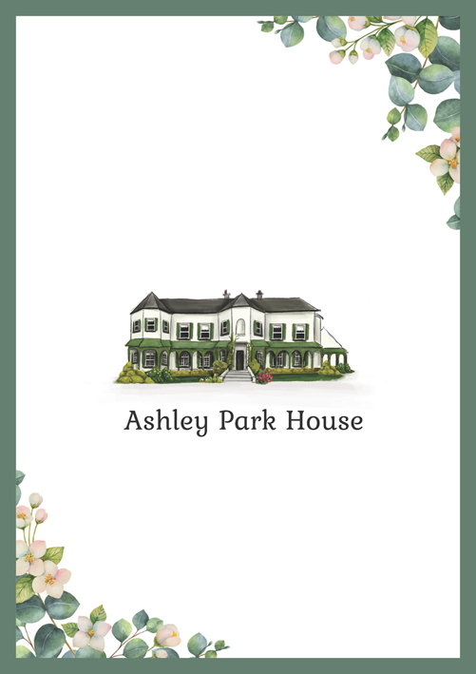

SAMPLE 2025

Accommodation is available at Ashley Park House.

Please let us know if you would like to stay the night of our wedding by emailing us on YOUREMAIL@YOUREMAIL.com with details of your reservation. Ashley Park House do not take wedding room reservations directly.

2025 B&B rates are €97.50 pp when two guests share a twin/double room. There are family rooms and single occupancy also available.

Guest arrival to Ashley Park House is from 2pm at the very earliest. Breakfast is 8.30am until 10.30am. Check out is by 11am in the Pavilion.

Whites