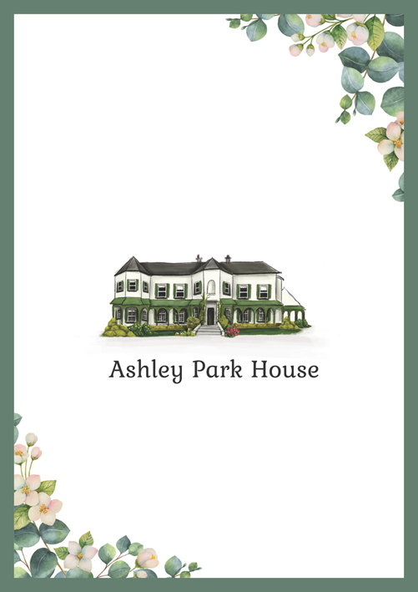

SAMPLE

Accommodation is available at Ashley Park House.

Please let us know if you would like to stay the night of our wedding by emailing us on YOUREMAIL@YOUREMAIL.com with details of your reservation. Ashley Park House do not take wedding reservations directly.

B&B rates are € pp when two guests share a twin/double room. There are family rooms and single occupancy also available.

Guest arrival to Ashley Park House is from 2.30pm and check in is after our ceremony.

Whites